

KGiSL INSTITUTE OF TECHNOLOGY

**Project_Title : Socioeconomic Analysis of Marginal Workers in Tamil Nadu: A Data-Driven**

**Approach**

**Mentor :** Indu Poornima R

**Team Members :**

ATHUL G NAIR

LAKSHMI NARAYANAN J

ARUN PRASATH K V

JOHN EDWIN A

**Project Description :** Socioeconomic Analysis of Marginal Workers in Tamil Nadu.

**Objective :**

To perform the demographic analysis and create visualization of marginal workers based on their age, industrial category and sex using data visualization libraries.

**Calculating the industrial category data :**

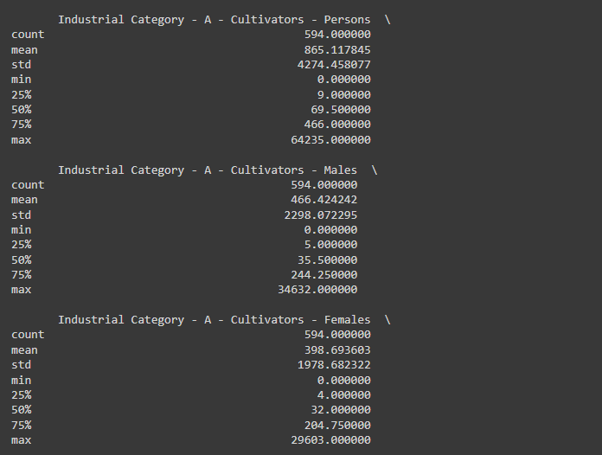

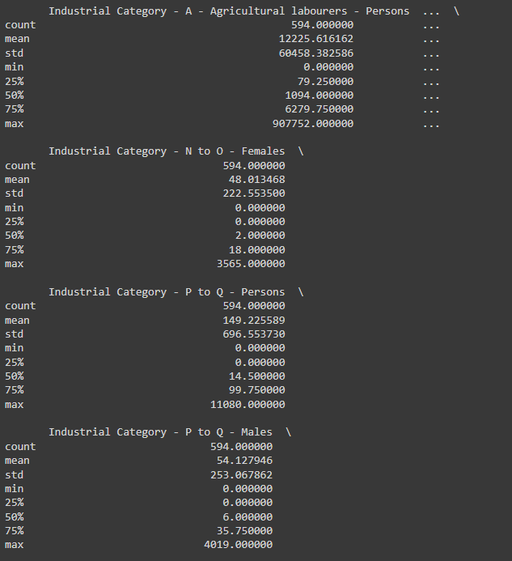

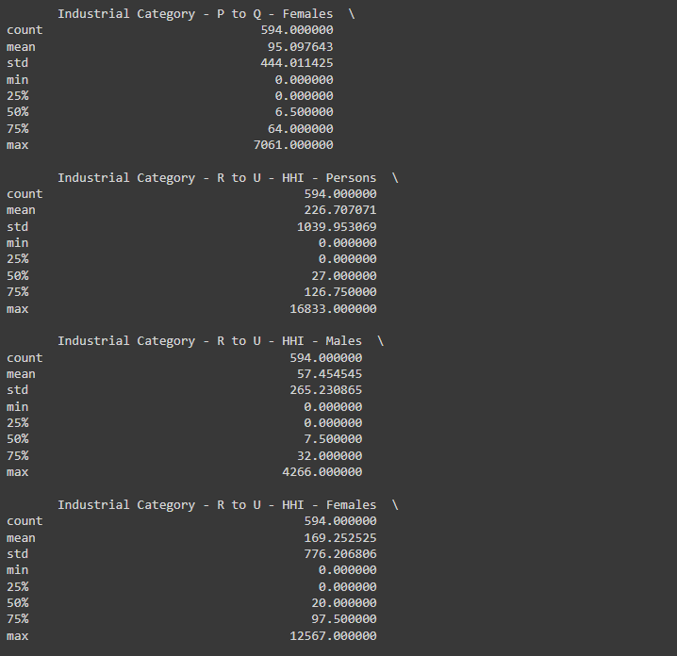

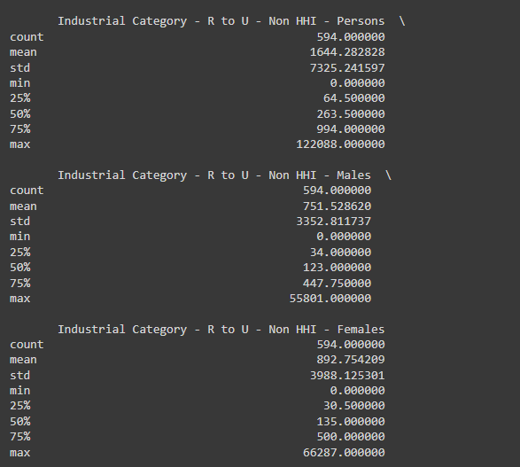

These are demographic analyses of marginal workers of Tamilnadu in the industrial category.

**Calculating the age group data :**

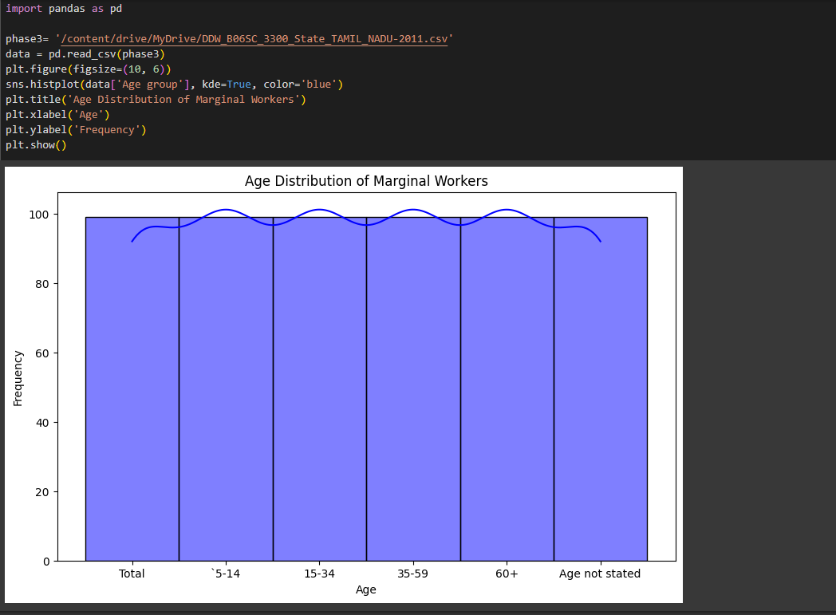

**Calculating the sex by dividing males and females :**

